**THANK YOU FOR DOWNLOADING!**

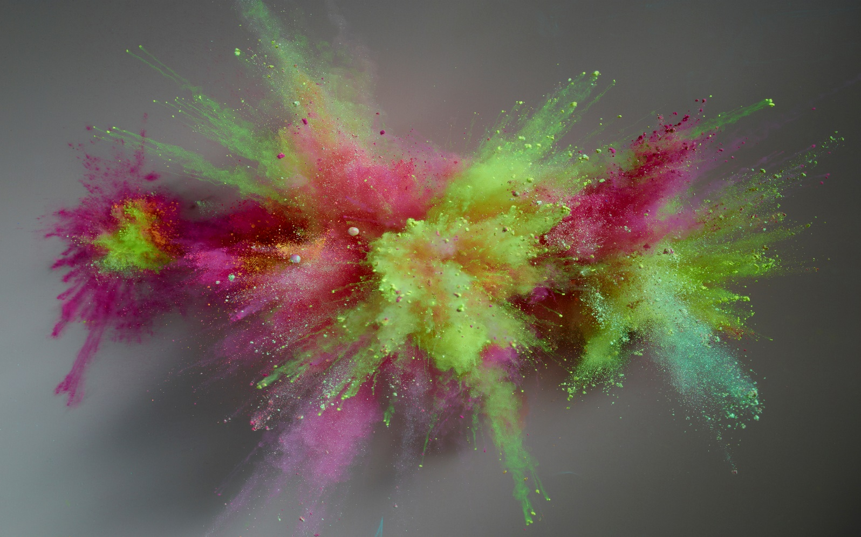

Do not worry, you have not downloaded anything but this doc. This is just here to simulate downloading the application. Thank you for looking at this project I worked on! – Gabriella (Gabby) Jugarap